Physics Seminar
Or Hen

Tel-Aviv University, Israel
" Short-range correlations in imbalanced Fermi systems”
Abstract:

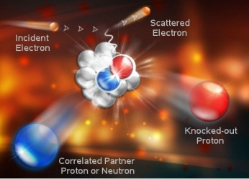
The atomic nucleus is composed of two different kinds of fermions, protons and neutrons. If the protons and neutrons did not interact, the Pauli exclusion principle would force the majority fermions, usually neutrons, to higher average momentum. In this talk I will present results from high-energy electron scattering experiments, which show that short-range interactions between the fermions form correlated, high-momentum, neutron-proton pairs. Thus, in neutron-rich nuclei the probability of finding a high-momentum (k>k_{Fermi}) proton (a minority Fermion) is greater than that of a neutron (a majority Fermion). This has wide ranging implications for atomic, nuclear and astro physics, including neutrino-nucleus scattering, the EMC effect, the NuTeV anomaly, the nuclear symmetry energy and more. This feature is universal for imbalanced interacting Fermi systems and can also be observed experimentally in two-spin states ultra-cold atomic gas systems.

Monday, November 24, 2014
11:00 am
CEBAF Auditorium

